**Pig - I**

**Student Name: Student Id:**

**Date:**

Please use the screenshots ONLY as a reference. The written instructions must be followed AS written.

PLEASE MAKE SURE YOU SUBMIT ALL THE SCREENSHOTS WITH TIMESTAMPS AT THE BOTTOM RIGHT (WINDOWS USERS) OR THE TOP RIGHT (MAC OSX USERS) OR ELSE YOU WILL AUTOMATICALLY QUALIFY FOR A DISCOUNT.

# Objective:

Pig is an engine for executing data flows in parallel on Apache Hadoop. It is used to read, process and store massive amounts of data. The objective of this exercise is to help the student become familiar with Pig. We will load the data in Pig and view it in HDFS.

**NOTE:**

* **Code to be executed is highlighted in Green**
* **The explanation for all the code is provided below the code**
* **There are subtle differences in HDFS commands and common Linux commands, if you are running into an error, or not seeing what you expect double check the commands**
* **The directory structure of HDFS has nothing to do with the directory structure of the local file system**
* **Some commands contain a (\) at the end of the first line, this signifies that the command is not complete. You may enter the code as it is shown on two lines or on one line without the “\”**
* **Maximize the terminal screen and increase the font to a visible size, otherwise points will be deducted**

Table of Contents

Objective: 1

Part-1: Setup: 3

Part-2: Working with Pig: 6

Part-3: Checksum: 8

ADDITIONAL NOTES: 11

Part-1: Setup: In this section we will setup the necessary data files for this assignment.

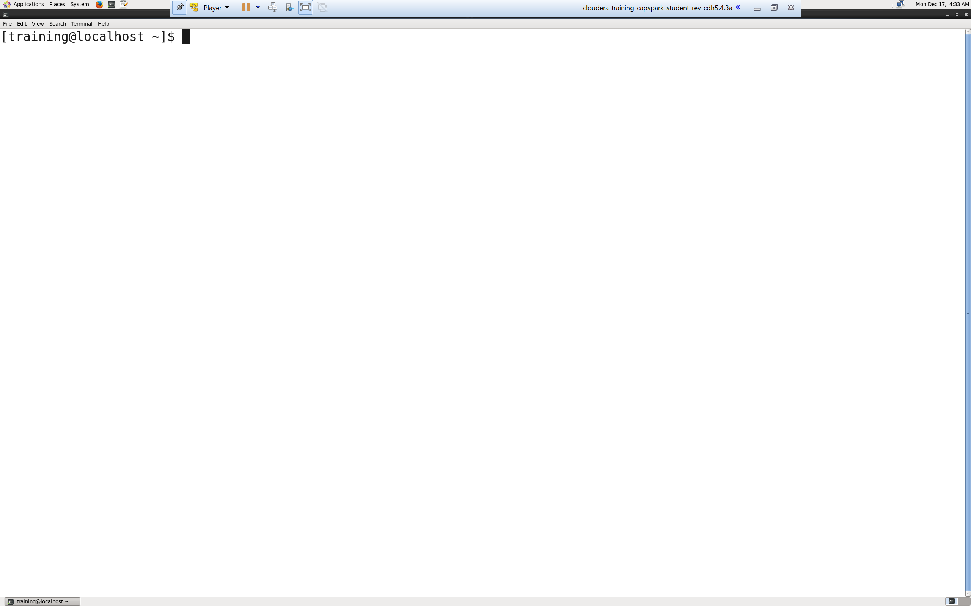Step-1: Start the Cloudera VM and then launch the “terminal” application.

Q. Take a screenshot of the terminal and paste it below.

Step-2: Download the Police_Incidents.zip file from eLearning in to the downloads folder IN the Cloudera VM using Mozilla Firefox.

Step-3: Execute the following command:





Q. Now type the command and execute. Take a screenshot of the shell output, highlight the zip file and paste it below.

Step-4: Execute the following command at the shell prompt:





Q. Now type the command and execute. Take a screenshot of the shell output, highlight the contents of the zip file and paste it below.

Explanation: The “unzip” command unzips the zip file.

Step-5: Execute the following command at the shell prompt



Explanation: The “cat” command is used to view data in files. The output of the “cat” command is redirected to the “awk” command using the pipe operator. The command that you have executed above gets data from Police_Incidents.tsv, performs clean operations on data and stores the output into a new file incidents_tab_clean.tsv.

A general overview of the commands used are:

* awk: OS command used to find any type of matching patterns in file or program
* RS: Record separator in an input file. Default value is new line
* ORS: Output Record separator. Default value is new line
* -v: Enables you to pass variables in your awk script
* gsub: Replaces every occurrence of input string with the required output string which specified in the command

NOTE:

* After “RS=” there is a single quote (‘) then a double quote (“)
* After the “*” there is a double quote (“) then a single quote (‘)
* There is a double space after (“$0”)
* There is a space before (“>incidents_tab_clean.tsv”)

Step-6: Execute the following command at the shell prompt:





Q. Now type the command and execute. Take a screenshot of the shell output and paste it below.

Explanation: The “-mkdir” command creates a directory on HDFS at the specified path with the specified name.

NOTE:

* Replace FirstName and LastName with your first name and last name, DO NOT copy as is.

Step-7: Execute the following command at the shell prompt:



Explanation: The “put” command is used to copy a local file or directory into HDFS. We are copying the file from our local directory to the HDFS in the

/FirstName_Lastname_incidents directory.

NOTE:

* Replace FirstName and LastName with your first name and last name, DO NOT copy as is.

Step-8: Open the “Mozilla Firefox” browser that is located at the top of the screen. Click on the bookmark called “HUE”

Q. Take a screenshot of the HUE splash screen and paste it below.

Step-9: In “HUE” browse to the directory that we created above in Step 6

Q. Take a screenshot of the directory and highlight the file that we copied.

Part-2: Working with Pig: In this section we are going to load the data that we cleaned above and stored in incidents_tab_clean.tsv in PIG using the Grunt shell and print 10 records to verify the same

Step-9: Launch the grunt shell



Q. Take a screenshot of the shell output and paste it below.

Explanation: Grunt is Pig’s interactive shell program. It is used to interact with HDFS directly. To enter Grunt type pig.

NOTE:

* To exit type quit or press <ctrl-d>

Step-10: Execute the following 4 commands at the shell prompt. Hit <enter> after each command



Q. Paste a screenshot of the shell output below.

Explanation:

Line 1: We are loading the data from tsv file into variable a. By default, Pig uses the PigStorage () load function.

Line 2-12: For each record in b, generate values as specified in the code e.g. incidentnumwithyear, year…. penaltyclass. It must be generated as per columns in tsv file.

Line 13-14: Print 10 records stored in c

NOTE:

* Replace FirstName and LastName with your first name and last name, DO NOT copy as is.
* Lines ending in a semicolon (‘;’) signifies the end of a command.

Part-3: Checksum: In this section we will perform a checksum

Step-11: Download the Checksum.zip file from eLearning in to the downloads folder **IN** the Cloudera VM using Mozilla Firefox.

Step-12: Execute the following command:



Q9. Now type the command and execute. Take a screenshot of the shell output, highlight the zip file and paste it below.

Step-13: Execute the following command at the shell prompt:



Q10. Now type the command and execute. Take a screenshot of the shell output, highlight the contents of the zip file and paste it below.

Explanation: The “unzip” command unzips the zip file.

Step-14: Execute the following command at the shell prompt:

Then execute the following command:

Q11. Take a screenshot of the shell output and paste it below.

Step-15: Execute the following command at the shell prompt:

rm Checksum.zip checksum.sh output.txt



Q12. Now type the command and execute. Take a screenshot of the shell output and paste it below.

# ADDITIONAL NOTES:

* Make sure to check the spelling before you execute a command, a spelling mistake in one step can snowball and prevent other steps from working.
* Execute means, type in the given command and hit return/enter
* Shell output refers to the output that you see in the terminal application after executing a command
* **SUBMIT A WORD DOCUMENT CONTAINING YOUR SCREENSHOTS IN ELEARNING.**
* **Also submit the Checksum value (32-bit alpha numeric key) from Step-14 in the comments section of the submission as shown in the screenshot below:**

